RFP Guide: SAP BW to Microsoft Fabric Migration
Oct 19, 2026 · @Raymon

1. Purpose and how to use this guide
This guide helps you write an RFP that returns comparable, priced bids for moving SAP BW data, logic and reporting to Microsoft Fabric and Power BI. Use sections 2–3 to structure and prepare the RFP, sections 4–9 as requirement text you can adapt, and sections 10–12 to price and score the bids. Replace every bracketed item with your own facts.
Why now: SAP BW standard maintenance is scheduled to end in 2027 (extendable to 2030), and BW/4HANA is supported much longer, to about 2040, according to element61. That timeline is why many organizations are tendering migrations now.
Assumptions in this guide:
- Source is SAP BW 7.x or BW/4HANA, [on HANA or other database].
- Target is Microsoft Fabric (OneLake, Data Factory, Lakehouse or Warehouse) with Power BI.
- Delivery is vendor-led, with your team taking over run and support.
- Connector and feature names are a starting point. Check them against current Microsoft Learn and SAP documentation before the RFP is issued.

2. Recommended RFP structure
A good RFP has nine sections, and the vendor response should mirror them so bids can be compared line by line.
# | RFP section | What it must contain
1 | Introduction and objectives | Business drivers, target outcome, measurable success criteria
2 | Current-state overview | Landscape facts from your discovery (section 3)
3 | Scope and out-of-scope | Workstreams, domains, waves, what stays in SAP
4 | Requirements | Functional, technical, security and non-functional requirements
5 | Delivery approach | Vendor method, phases, governance, knowledge transfer
6 | Vendor profile and team | References, named roles, certifications
7 | Commercials | Pricing template, assumptions, change control
8 | Evaluation and process | Criteria, weights, timeline, contacts, Q&A rules
9 | Appendices | Questionnaire, data inventory, NDA, contract terms
Share the detailed BW inventory only after the vendor signs an NDA. Ask vendors to answer in a fixed response template, with a separate pricing file.

3. Discovery: what to inventory before you issue the RFP
Vendors price what they can count, so a thin inventory produces padded bids or a wide range of prices. Collect the facts below, and mark anything unknown as an assumption the vendor must price against.
Area | What to capture | Why it drives the bid
InfoProviders | Counts by type (ADSO/DSO, InfoCube, CompositeProvider, InfoObject), size in GB, row counts, history depth | Sizing, load times, Fabric capacity
Transformations | Number of transformations, ABAP start/end/field routines, DTPs | Rebuild effort, the largest cost driver
Process chains | Count, schedules, dependencies, failure handling | Orchestration redesign
Extractors and sources | Standard vs custom extractors, delta types, source systems (ECC, S/4HANA, files, non-SAP) | Choice of extraction method
Queries and reports | BEx queries, Analysis for Office workbooks, BusinessObjects reports, usage over the last 12 months | Retire unused items, prioritize the rest
Authorizations | Analysis authorizations, roles, user counts | Row-level and object-level security redesign
Planning and write-back | BW-IP, BPC or other planning functions | Often not a Fabric fit, so decide scope early
Service levels | Refresh windows, concurrency, availability, retention | Architecture and capacity
Downstream consumers | Excel, APIs, other systems fed by BW | Hidden integrations that break at cutover
Use BW query runtime statistics (such as RSDDSTAT) to find which queries are actually used. Reports with no recent use are candidates to retire instead of migrate, which reduces scope.
Also record your S/4HANA roadmap, because it changes which source systems you will extract from during and after the migration.

4. Scope of services
Ask vendors to price nine workstreams separately, so you can compare bids and drop or re-sequence parts. Each row needs an acceptance test your team can verify.
Workstream | Vendor must deliver | Acceptance evidence
1. Assessment and roadmap | Inventory, classification (migrate, rebuild, retire), wave plan, risk register | Signed-off inventory and wave plan
2. Target architecture and design | Fabric workspace and capacity design, medallion layers, naming, CI/CD, governance model | Architecture document approved by your design authority
3. Extraction and ingestion | Initial and delta loads from SAP into OneLake, scheduling, error handling | Loads run unattended, row counts match source
4. Transformation rebuild | BW transformations and routines rebuilt in Spark notebooks or SQL, with lineage | Output matches BW within agreed tolerance
5. Semantic layer and reporting | Power BI semantic models, reports and paginated reports replacing BEx and BusinessObjects | Business users sign off each report in UAT
6. Security and governance | Mapping of BW authorizations to Fabric and Power BI security, sensitivity labels, audit | Security tests pass, access review done
7. Testing and reconciliation | Automated reconciliation against BW, performance tests, UAT support | Reconciliation report per domain
8. Cutover and decommission | Parallel run, cutover plan, rollback plan, BW retirement plan | Go-live criteria met, BW read-only
9. Training, documentation, hypercare | Runbooks, admin and developer training, a defined hypercare period | Your team operates the platform without vendor help
State explicitly what is out of scope, for example BW planning, SAP-side changes, S/4HANA migration, and Fabric capacity purchase. Anything unstated will come back as a change request.

5. Target architecture requirements
Fabric holds all BW data in OneLake and rebuilds BW logic in the silver layer, with Power BI as the only serving layer. Ask vendors to confirm or improve this reference design.
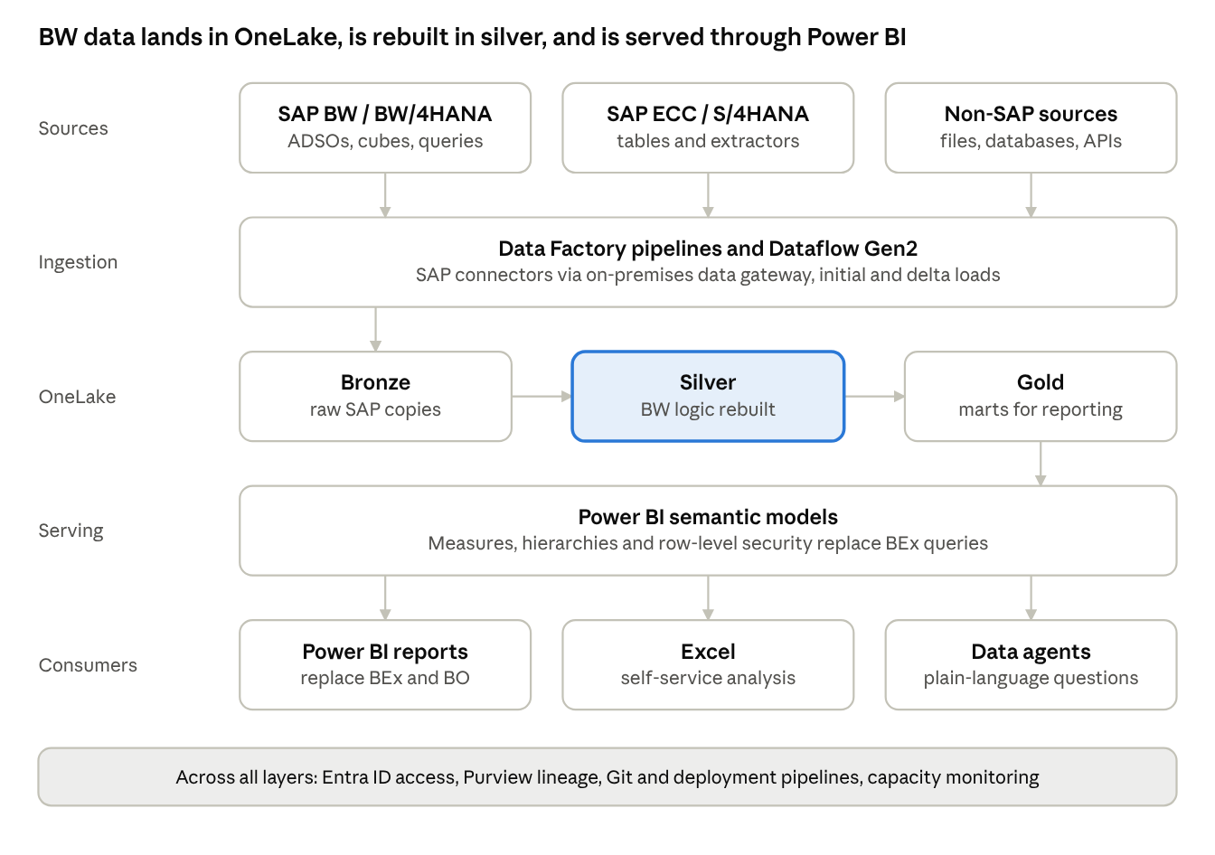
reference architecture · 5 layers
Data enters through Data Factory pipelines and Dataflow Gen2, passes through bronze, silver and gold layers in OneLake, and reaches users through Power BI semantic models.
Requirements to put in the RFP:
- Layering: bronze holds a raw copy of SAP data, silver holds cleansed data with BW transformation logic rebuilt, gold holds business marts. The vendor states what is stored where and why.
- Store choice: justify Lakehouse versus Warehouse per layer, given your team's Spark and SQL skills [fill in].
- Semantic models: one governed model per business domain on gold tables, with a plan for hierarchies, restricted and calculated key figures, and exception aggregation.
- Capacity: a sizing proposal for Fabric capacity covering load, transformation and query peaks, plus a monitoring and cost-control approach. You buy the capacity, not the vendor.
- Environments: separate dev, test and prod workspaces, Git integration, deployment pipelines and naming standards.
- Performance: partitioning, incremental refresh, and Direct Lake versus Import choices explained per model.
- Service levels: refresh window [x hours], report response time [x seconds], availability [x %], retention [x years].

6. SAP extraction and integration requirements
The extraction method decides cost, load time and how well delta loads work, so make vendors justify their choice per source instead of naming one tool. A published BW-to-Fabric implementation used Dataflow Gen2 with the SAP BW Application Server connector to pull cube data from a BW query into a Lakehouse, which suits prototypes and query-level extracts.
Option | Best for | Watch-outs
Dataflow Gen2 with the SAP BW connector | Query-level extracts, prototypes, smaller volumes | Volume limits, BW query variables, less suited to detail-level history
Data Factory pipelines with SAP connectors (Table, Open Hub, CDC/ODP) | Bulk and delta loads of detailed data | Needs a data gateway and SAP-side setup, check current connector availability in Fabric
BW Open Hub destinations to files or tables | Scheduled batch extracts of ADSOs and InfoProviders | BW-side configuration and extra storage
SAP Datasphere replication flows | Organizations that already license Datasphere | Additional license and platform to run
Third-party extractors | Very high volumes or tight latency | Extra license cost and vendor lock-in
This table is general knowledge, so verify current connector support on Microsoft Learn before finalizing.
Requirements to include:
- Initial load and delta strategy per source, including how deletions and reversals are handled.
- Impact on the SAP system: expected load, extraction windows, and who approves them.
- Connectivity: gateway design, network path, authentication, and high availability.
- Licensing: confirmation that the extraction method complies with your SAP license terms for third-party access.
- Reconciliation built into every load: row counts and control totals compared with BW.
- Restart and retry behavior, alerting, and monitoring for failed loads.
- Handling of SAP specifics: fiscal year variants, currency and unit conversion, time-dependent attributes, and hierarchies.

7. Migration approach and phasing
Require a wave-based migration with a pilot domain first, a parallel run, and a formal gate between phases. The durations below are illustrative, so ask each vendor to propose and justify its own.
- Mobilize and assess (about 4–8 weeks). Inventory, classification, wave plan. Gate: signed-off inventory and wave plan.
- Foundation (about 4–6 weeks). Fabric capacity and workspaces, security baseline, CI/CD, one thin end-to-end slice from SAP to a Power BI report. Gate: the slice runs unattended and reconciles.
- Pilot wave (about 8–12 weeks). One business domain, for example sales, built fully. Gate: outputs reconcile to BW and business users accept the reports.
- Scale waves (repeated per domain). Reuse the pilot patterns, a fixed gate per wave. Gate: same acceptance tests as the pilot.
- Parallel run (at least one period-end close). BW and Fabric run side by side. Gate: variances within the agreed tolerance and every difference explained.
- Cutover, decommission and hypercare. BW becomes read-only, then is retired on a dated plan. Gate: your team runs operations, with a rollback plan tested before go-live.
Put these rules in the RFP:
- Reconciliation: define the tolerance up front, for example zero variance on financial totals and a stated rounding rule elsewhere, and require automated reconciliation reports.
- Retire before you migrate: the vendor must challenge every report and data object, and only migrate what is used.
- Coexistence: BW and Fabric run in parallel for a defined period, so ask for a plan for the cost and for keeping changes in sync.
- Change freeze: agree a freeze on new BW development once a domain's wave starts.

8. Security, governance and compliance
BW authorizations do not carry over to Fabric, so security must be redesigned and tested, not copied. Make the vendor responsible for mapping the old model to the new one.
- Identity and access: Microsoft Entra ID for authentication, groups mapped to workspace roles and items.
- Data-level security: row-level and object-level security in Power BI semantic models, built from a documented mapping of BW analysis authorizations, with test cases per role.
- Data protection: sensitivity labels, encryption, and rules for personal and confidential data under GDPR and your internal policies [list].
- Data residency: Fabric capacity region and OneLake storage location must meet [region or legal requirement].
- Lineage and cataloging: end-to-end lineage from SAP source to report, using Microsoft Purview or equivalent.
- Audit and monitoring: activity logs retained for [x] months, alerts on failed loads and unusual access.
- Governance model: workspace ownership, naming, certified versus personal content, and a process for requesting new data.
- Financial controls: if the data supports financial reporting, evidence for change control and segregation of duties [SOX or equivalent].
- Resilience: backup, recovery and disaster-recovery approach, with recovery time and recovery point targets [x].

9. Vendor qualifications, team and references
The vendor needs both SAP BW depth and Fabric depth, and few firms have equal strength in each. Ask for evidence of both, and for named people instead of role descriptions.
- References: at least [2–3] comparable migrations from SAP BW or BW/4HANA to a modern platform, with scale (number of objects, data volume, users), duration and a reference contact. Ask separately for Fabric and Power BI references.
- Certifications: Microsoft Fabric and Power BI certifications for the proposed team, for example Fabric Data Engineer, Fabric Analytics Engineer and Power BI Data Analyst, and SAP BW experience of the people who read the BW side.
- Named team: ask for CVs of the people who will actually do the work, a stated onshore and offshore split, and a key-person clause with replacement terms.
- Partner status: Microsoft partner level and any SAP partner status.
- Methods and accelerators: tools for automated inventory, code conversion and reconciliation, with a clear statement of what is automated and what is manual. Treat claims of fast, AI-driven migration as claims to test in the proof of concept.
- Financial and legal standing: company size, insurance, and subcontracting rules.
Role | What to ask
Engagement lead | Named person, time commitment, similar programs led
SAP BW architect | BW and BW/4HANA experience, extraction design
Fabric architect | Fabric solution architecture, capacity sizing
Data engineers | Spark, SQL and pipeline experience, headcount per phase
Power BI developers | Semantic modeling, DAX, row-level security
Test and reconciliation lead | Automated reconciliation experience

10. Commercial model and pricing template
Ask for a fixed price per phase or wave, plus a rate card for changes, in a separate pricing file the vendor fills in. A fixed price only works if the scope is counted, so tie each price to the object counts from your inventory.
Workstream or wave | Fixed price | Duration | Effort (days) by role | Key assumptions
1. Assessment and roadmap | [ ] | [ ] | [ ] | [ ]
2. Foundation | [ ] | [ ] | [ ] | [ ]
3. Pilot wave | [ ] | [ ] | [ ] | [ ]
4. Each scale wave | [ ] | [ ] | [ ] | [ ]
5. Parallel run and cutover | [ ] | [ ] | [ ] | [ ]
6. Hypercare | [ ] | [ ] | [ ] | [ ]
Training and documentation | [ ] | [ ] | [ ] | [ ]
Terms to require:
- Rate card by role, valid for [x] months, for work outside the fixed scope.
- Milestone payments tied to your acceptance of deliverables, with a retention of [x %] until hypercare ends.
- Change control: how scope changes are priced and approved, and what counts as a change.
- Warranty: a defect-fix period after go-live at no extra charge [x months].
- Platform costs shown separately: the vendor estimates Fabric capacity, SAP-side and gateway costs, but you buy them.
- Optional items priced separately, for example additional waves, extended hypercare, and managed services after go-live.
- Expenses and travel: capped or excluded.
- Intellectual property: you own code, notebooks, models and documentation produced for you.

11. Evaluation criteria and scoring
Publish the criteria and weights in the RFP, so vendors know what matters and your decision can be defended. The weights below are a starting point; adjust them to your priorities.
Criterion | Weight | What a top score looks like
Technical approach and architecture | 25 % | Clear design, sound extraction and reconciliation approach, realistic about BW complexity
SAP BW expertise and migration method | 20 % | Proven method, tools that cut manual effort, a plan to retire unused objects
Fabric and Power BI expertise | 15 % | Certified team, comparable Fabric delivery, capacity and governance design
Team and references | 15 % | Named senior team, relevant references that check out
Price | 15 % | Complete, comparable, transparent assumptions
Risk, governance and knowledge transfer | 10 % | Credible risk plan, handover to your team, clear acceptance
Score each criterion from 0 to 5 using written definitions, and have each evaluator score alone before the group compares results.
Use a staged process:
- Written responses are scored against the criteria.
- A shortlist of 2–3 vendors gives demos and answers follow-up questions.
- A paid proof of concept of 1–2 weeks on the same sample for each vendor, for example one ADSO, its transformation and one query rebuilt in Fabric.
- Reference calls, then negotiation and award.
The proof of concept is the best test of claims about automation and speed, because every vendor does identical work on your real objects.

12. Timeline, risks and common pitfalls
Plan about 10–12 weeks from issuing the RFP to award, and leave the vendor at least three weeks to respond to a program of this size. Typical steps:
- Week 0: issue the RFP and NDA, share the inventory with signed vendors.
- Weeks 1–2: vendor questions, with all answers shared with every bidder.
- Week 4–5: responses due.
- Weeks 5–7: scoring and shortlist.
- Weeks 7–10: demos and the paid proof of concept.
- Weeks 10–12: reference calls, negotiation and award.
Risk | Mitigation to build into the RFP
Hidden ABAP and custom logic inflates effort | Inventory routines before issue, price rebuild per routine band, review in the pilot
Numbers do not match BW | Agreed tolerance, automated reconciliation, a parallel run through a period close
Security gaps after cutover | Role-by-role test cases, security sign-off as a go-live gate
Fabric capacity cost overruns | Vendor sizing, monitoring, capacity reviews each wave
Scope creep from migrating everything | Retire-first rule, usage data, a change-control process
Business users reject new reports | Users in the pilot UAT, training, a named business owner per domain
SAP licensing or extraction limits | Early licensing check, SAP Basis involvement, extraction windows
Key people leave the vendor | Named team, replacement and notice terms
Common pitfalls:
- Asking for a fixed price without an inventory, which gets padded or incomparable bids.
- Treating the migration as a report copy, so the BW semantics (hierarchies, exception aggregation, currency conversion) are lost.
- Leaving planning and write-back out of the discussion until late.
- No named business owners, so nobody accepts the reports.
- Scoring on price alone, when rebuild quality decides total cost over the next years.

13. Appendix: checklists and vendor questionnaire

Before you issue the RFP
- ☐ BW inventory complete (section 3), with usage data for queries
- ☐ Out-of-scope items decided (planning, S/4HANA migration, capacity purchase)
- ☐ Business owner named for each domain
- ☐ Security and compliance requirements reviewed with your security team
- ☐ SAP Basis team and SAP licensing contact consulted on extraction
- ☐ Evaluation team, criteria and weights agreed before bids arrive
- ☐ NDA and pricing template ready

Questions every vendor must answer
- Describe your method for migrating SAP BW to Fabric, from assessment to decommission.
- Which extraction approach would you use for each of our source types, and why?
- How do you handle delta loads, deletions and reversals?
- How do you rebuild BW transformations and ABAP routines, and how much is automated?
- How do you reproduce hierarchies, restricted and calculated key figures, and exception aggregation in Power BI?
- How do you map BW analysis authorizations to Fabric and Power BI security?
- How do you prove that the numbers match BW, and what tolerance do you propose?
- What Fabric capacity do you expect us to need, and how did you size it?
- How do you decide which reports and objects to retire?
- Describe the team: named roles, location, availability and time commitment.
- Give three comparable references, with contact details.
- What do you need from our team, in people and time, during each phase?
- What are your top five risks for this program, and how will you manage them?
- How do you transfer knowledge so that we can run the platform ourselves?
- State your assumptions, exclusions and what would change your price.
- What is your approach to a parallel run and rollback at cutover?
- How will you support us after go-live, and for how long?

